August 26th 2016
Dear Colleagues,
I am writing to you today to request your assistance in identifying candidates for a several Postdoctoral Associate positions in LaCNS (Louisiana Consortium for Neutron Scattering) a DOE-EPSCoR program focused on building a neutron scattering effort in the state of Louisiana in hard and soft materials. We are interested in hiring PhD scientists with experience in experimental condensed matter physics (hard materials). Experience in neutron scattering techniques, physical characterization, and/or single crystal synthesis techniques are valued but not required for this position. The successful candidate will be involved in research projects which explore the dynamics and structure of magnetic and superconducting materials. Postdoc may be expected to travel to Oak Ridge National Laboratory to perform neutron scattering experiments.
The research projects that will be pursued include explorations of transition metal oxides, silicides, germanides, gallides, etc. by way of magnetization, carrier transport, specific heat, magnetic force microscopy, as well as elastic and inelastic neutron scattering. Posdocs will be intimately involved in the synthesis of polycrystalline and crystalline materials for exploration. In addition, we expect that the postdoc will be responsible for assisting in the training of graduate students in experimental techniques and analysis as an integral part of the research program. We are confident that this will be a positive research experience for a talented scientist and that participation in our program will lead to opportunities for the postdoc to advance their career.
We require that applicants either have completed their PhD program, or will be completing their PhD work in the next few months, and have experience in experimental condensed matter physics. Experience in neutron scattering and in single crystal synthesis in their previous research is desired, but not required. We include some details below taken from an online advertisement. Applications can be made by visiting the following web sites:
https://lsu.wd1.myworkdayjobs.com/LSU/job/LSU---Baton-Rouge/Postdoctoral-Researcher-Senior-Postdoctoral-Researcher_R00004511-1
https://lsu.wd1.myworkdayjobs.com/LSU/job/LSU---Baton-Rouge/Postdoctoral-Researcher-Senior-Postdoctoral-Researcher_R00004418
or
https://lsu.wd1.myworkdayjobs.com/LSU/job/LSU---Baton-Rouge/Postdoctoral-Researcher-Senior-Postdoctoral-Researcher_R00004398
We encourage interested parties to contact us directly through email at ditusa@physics.lsu.edu or rjin@ lsu.edu for more information.
We thank you for your time and attention to our request and look forward to either hearing from you about candidates who may have an interest, or from the potential candidates themselves.
Sincerely,
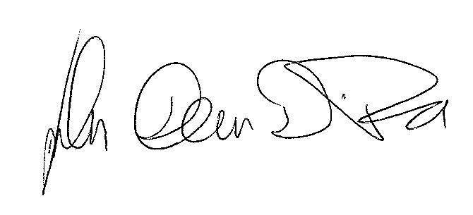
John F. DiTusa for
Rongying Jin
Ward Plummer
David Young
Jiandi Zhang

Advertisement for Postdocs for LaCNS

Description of Position:
The experimental Condensed Matter Physics group at Louisiana State University, Baton Rouge, has immediate openings for several postdoctoral Research Associates. These positions are supported by grants from the US Department of Energy and the State of Louisiana Board of Regents for novel magnetic and superconducting materials development. We seek candidates with experience in one or more of the following: single crystal growth, crystal and magnetic structural investigations employing neutron and X-ray scattering, and low temperature measurements such as charge transport, magnetometry, magnetic force microscopy, and specific heat. A portion of this work is done in collaboration with Oak Ridge National Laboratory and travel to Oak Ridge is likely. We seek creative, self-motivated experimentalists with the ability to work both independently and as a part of a team, with an interest in pursuing challenging, interdisciplinary research.

Qualifications:
We require that applicants either have completed their PhD program, or will be completing work in the next few months, and have experience in experimental condensed matter physics. Experience in neutron scattering and in single crystal synthesis is desired.

Application Process:
We encourage interested parties to contact us directly through email at ditusa@physics.lsu.edu or rjin@ lsu.edu.
For immediate consideration, please apply at https://lsu.wd1.myworkdayjobs.com/LSU/job/LSU---Baton-Rouge/Postdoctoral-Researcher-Senior-Postdoctoral-Researcher_R00004511-1
https://lsu.wd1.myworkdayjobs.com/LSU/job/LSU---Baton-Rouge/Postdoctoral-Researcher-Senior-Postdoctoral-Researcher_R00004418
or
https://lsu.wd1.myworkdayjobs.com/LSU/job/LSU---Baton-Rouge/Postdoctoral-Researcher-Senior-Postdoctoral-Researcher_R00004398

